

MSP - 010

PROCEDURE FOR OUTSOURCING SAMPLES TO AN APPROVED EXTERNAL LABORATORY

TABLE OF CONTENTS

TABLE OF CONTENTS 2
APPROVAL AUTHORITY 3
RECORD OF AMENDMENTS 4
DISTRIBUTION LIST 5
LIST OF ABBREVIATIONS 6
1. Objective 7
2. Scope 7
3. Responsibilities 7
4. Definitions 8
5. Procedure 8
6. Quality Control 13
7. Related Documents 13
8. Reference Regulations & Guidelines 14
9. Related Records 14
Process Flow of Sample Outsourcing 15

Prepared by: | Quality Manager | Name | Date:
 |  | Signature
Reviewed & Issued by: | Laboratory Head |  | Date:
 |  | Signature
Approved by: | Chairman & Managing Director | Mr. Venkata Cherukuri  Name | Date:
 |  | Signature

APPROVAL AUTHORITY

RECORD OF AMENDMENTS

S. No. | Ver. No. | Ver. Date | Rev. No. | Rev. Date | Description of Changes

Document Copy No. | Name / Designation of the holder of the document copy | Type of Copy | Version No. | Revision No.
01/10 | Managing Director | Controlled Copy | 01 | 00
02/10
03/10
04/10
05/10
06/10
07/10
08/10
09/10
10/10

DISTRIBUTION LIST

LIST OF ABBREVIATIONS
S. No. | Abbreviations | Expansion
1 | CSD | Customer Service Department
2 | FOM | Form
3 | GE | General
4 | HOD | Head of Department
5 | ISO | International Organization for Standardization
6 | IT | Information Technology
7 | LIMS | Laboratory Information Management System
8 | MSP | Management System Procedure
9 | MAN | Manual
10 | NABL | National Accreditation Board for Testing and Calibration Laboratories
11 | NRL | National Reference Laboratory
12 | QA | Quality Assurance
13 | SOP | Standard Operating Procedure
14 | TRF | Test Requisition Form
15 | TDPL | TRUSTlab Diagnostics Private Limited

- Objective
The objective of this standard operating procedure is to provide guidelines for team members on collecting and distributing samples to an outsource lab for processing.
- Scope
This SOP applies to the following:
A. | Parameter tagged for outsourcing due to lack of internal processing capabilities.
i) | Single test samples – all tests outsourced
ii) | Multiple test sample – all tests are outsourced
iii) | Multiple test samples – partially outsourced, partially in-house
B. | Parameters referred to outsourcing due to machine breakdown/shortages of reagent or manpower before sample registration.
i) | Single test samples – all tests outsourced
ii) | Multiple test sample – all tests are outsourced
iii) | Multiple test samples – partially outsourced, partially in-house
C. | Parameters referred to outsourcing due to unexpected machine breakdown after the samples are registered and received into the department.
i) | Single test samples – all tests outsourced
ii) | Multiple test sample – all tests are outsourced
iii) | Multiple test samples – partially outsourced, partially in-house
- Responsibilities
  - Accession Department
  - Customer Service Department
  - Processing-department Staff
  - Lab Manager
  - Lab Head
- Definitions
Outsourcing: The process of sending a sample to an external referral lab for testing.
Sample: A biological specimen of a patient/test requestor that is received by TRUSTlab for specific diagnostic testing.
- Procedure
- Once the sample is dropped off at Accession, the team at Accession should carry out routine sample pre-processing & checking as per SOP.
- If the sample passes the routine checks, the accession team will register the sample in the LIMS software.
- If the sample is tagged as an outsourced sample in the LIMS software, check if all the tests of the sample should be outsourced or if partial tests are to be done in-house and partially outsourced.
- Parameter Tagged for Outsourcing due to lack of internal processing capabilities:
  - If all the tests of the sample are to be outsourced (both Single Test or Multiple Test Samples):
    - After sample registration, fill in the tagged outsourced partner TRF with all the details including complete patient details, outsource lab Test code and Test names written clearly and completely.
    - If the Test Code & Name are not known, get the information from CSD.
    - Place the sample/s in a sealed plastic bag along with the duly filled TRF and place it in the fridge in the Accession department.
    - Accession team will enter all the details in the Outsource Sample Register (TDPL/AS/REG-005).
    - Inform CSD about the outsource sample receipt and its readiness to be dispatched. (through ticketing / WhatsApp group).
    - When the relevant outsource lab rider arrives at NRL, the CSD team member stationed at NRL picks up the samples from the Accession department and hands them over to the rider. (In the event that the CSD member isn’t available, an Accession team member performs this task.)
    - The Accession team will ensure that the CSD team member signs in the Outsource Sample Register (TDPL/AS/REG-005) before handing over the samples and register to him/her.
    - The CSD team member will fill in the Outsource Sample Register (TDPL/AS/REG-005) and get it signed by the outsource rider before handing over the sample package to him/her. Once the samples are handed over, this information is passed onto the CSD (through LIMS/WhatsApp/ticketing) for tracking and follow-up.
    - The register is placed back at the Accession department, by the CSD member.
  - If partial tests of the sample are to be outsourced and the other tests are in-house tests:
    - During registration the Accession team shall note the samples that have tests that are to be partially outsourced and partially processed in-house (within the same department or in a different department).
    - The Accession team will check for the adequacy of the sample received to be processed both in-house and at an outsource location.
    - If the sample is in adequate quantity, an Accession team member may stick a RED coloured sticker to the sample tube to identify that it is a shared sample (between in-house and outsourced locations) and must therefore be processed on priority.
    - The sample vacutainer is then placed in the WHITE Tube-Stand and sent to the relevant internal department for processing on a priority basis.
    - Once the internal tests are completed, the sample is returned to the Accession department in the WHITE Tube-Stand for it to be outsourced. The department digitally transferring the sample back to the Accession department is responsible for physically returning the sample to Accession and for signing in the Outsource Sample register.
    - The Accession team will get the sample ready for outsourcing as outlined in point 5.4a of this SOP.
- Parameters Referred for Outsourcing due to machine breakdown/shortages of reagent or manpower before sample registration
  - If all the tests of the sample are to be outsourced (both Single Test / Multiple Test Samples):
    - The department where the machine has broken down or is under maintenance should notify the Accession and CSD departments immediately (within 5-10 minutes) of the situation. Subsequently, it is also the responsibility of the said department to notify the Accession team & CSD immediately after the machine gets fixed and becomes operational.
    - After sample registration, the Accession team will fill in the allocated outsourced partner TRF with all the details including Complete patient details, outsourced partner Test code and Test names written clearly and completely. Place the sample/s in a sealed plastic bag along with the duly filled-in TRF and place it in the fridge in the accession department.
    - The rest of the procedure will be as described in Section 5.4a.
  - If partial tests of the sample are to be outsourced and the other tests are in-house tests:
    - During sample registration, the Accession team shall note the samples that have tests that are to be partially outsourced and partially processed in-house (within the same department but on a different machine or in a different department).
    - The accession team will check for the adequacy of the sample received to be processed both in-house and at an outsourced location.
    - The rest of the procedure will be as described in section 5.4b.
- Parameters Referred for Outsourcing due to unexpected machine breakdown after the samples are registered and received into the department
  - If all the tests of the sample are to be outsourced (both Single Test / Multiple Test Samples):
    - The department where the machine breakdown occurred shall immediately notify the Accession and CSD departments about the break-down incident. The department will send the samples back to the Accession department to initiate the outsourcing process. It is the responsibility of the department to note the samples in the Inter-Department Sample Transfer Register (TDPL/GE/REG-009) and get the Accession team to sign upon receipt at the Accession department.
    - The Accession team will change the sample registration details in the LIMS and tag the sample as an outsourced sample.
    - The Accession team will check for the allocated outsource partner in LIMS before filling in the outsourced partner TRF with all the details including Complete patient details, outsourced partner Test code and Test names written clearly and completely. Place the sample/s in a sealed plastic bag along with the duly filled-in TRF and place it in the fridge in the accession department.
    - Inform CSD about the outsource sample receipt and its readiness to be dispatched. (through ticketing / WhatsApp group).
    - The rest of the procedure will be as described in section 5.4a (iv) onwards.
  - If partial tests of the sample are to be outsourced and the other tests are in-house tests:
  - In the situation where the machine breakdown has happened is the first department to process a multi-department sample:
    - The department where the machine breakdown occurred shall immediately notify the Accession and CSD departments about the break-down incident. The department will send the samples back to the Accession department to initiate the outsourcing process. It is the responsibility of the department to note the samples in the Inter-Department Sample Transfer Register (TDPL/GE/REG-009) and get the Accession team to sign upon receipt at the Accession department.
    - The Accession team will check for the adequacy of the sample received to be processed both in-house and at an outsourced location.
    - The Accession team will change the sample registration details in the LIMS and tag those particular tests that were to be tested on the breakdown machine as outsourced tests.
    - If the sample is in adequate quantity, an Accession team member may stick a RED coloured sticker to the sample tube to identify that it is a shared sample (between in-house and outsourced locations).
    - The sample vacutainer is then placed in the WHITE Tube-Stand and sent to the relevant internal department for processing on a priority basis.
    - Once the internal tests are completed, the sample is returned to the Accession department in the WHITE Tube-Stand for it to be outsourced. The department transferring the sample back to the Accession department is responsible for physically returning the sample to the Accession and getting the Accession team to sign in the Inter-Department Sample Transfer Register (TDPL/GE/REG-009).
    - The Accession team will get the sample ready for outsourcing as outlined in point 5.4 of this SOP.
- Task-wise Responsibility

S. No. | Task | Responsibility
1. | Handover of sample to outsource lab Rider. | Front office at Lab
2. | Arrange the outsource rider and ensuring that sample is picked up. | Front office at Lab
3. | Billing at the outsource lab, Report follow up at the outsource lab, Report in pdf to be shared to department. | CSD
4. | Check if any changes in reference ranges/Units and method, technical department will inform HOD and immediately raise the ticket for changes to the IT department. | Technical Dept
5. | Ticket must be assigned to IT directly and after changes are made, report values are entered, and approval is requested to the HOD. | Technical Dept
6. | Check the outsource report and enter the values in result entry page. | Technical Dept
7. | Check outsource report and TRUSTlab report format before final approval. | HOD/Consultant
- Quality Control
The Quality Manager or designee will do random Quality Control checks to ensure that this SOP is implemented as written. If Quality control checks reveal non-compliance with this SOP, the SOP deviations and violations will be investigated, corrective and preventive action initiated, implemented, reviewed and closed out. All corrective and preventive action will be documented in the Non-Conformity & Corrective Action Form (TDPL/GE/FOM-021).
- Related Documents
N/A.
- Reference Regulations & Guidelines
  - Specific Criteria for Accreditation of Medical Laboratories (NABL 112 A; Issue 01)
  - Guidance document: Medical Laboratories (NABL 112B; Issue 01)
  - ISO 15189:2022 Medical Laboratories – Requirements for Quality and Competence
- Related Records
  - Non-Conformity & Corrective Action Form (TDPL/GE/FOM-021)
  - Inter-Department Sample Transfer Register (TDPL/GE/REG-009)
  - Outsource Sample Register (TDPL/AS/REG-005)

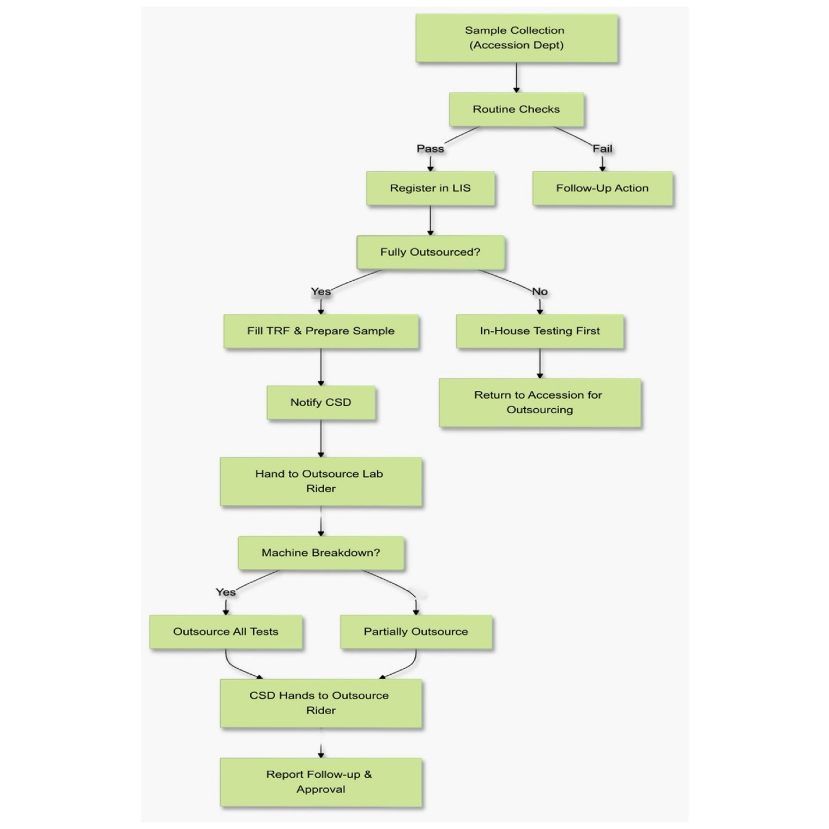
Process Flow of Sample Outsourcing

